1. Spike Version
2. 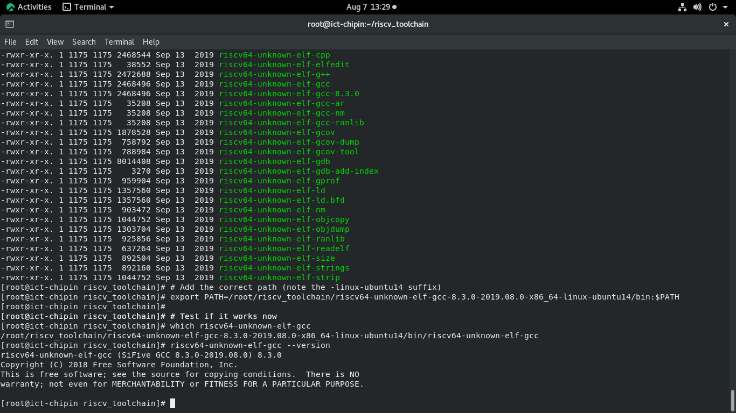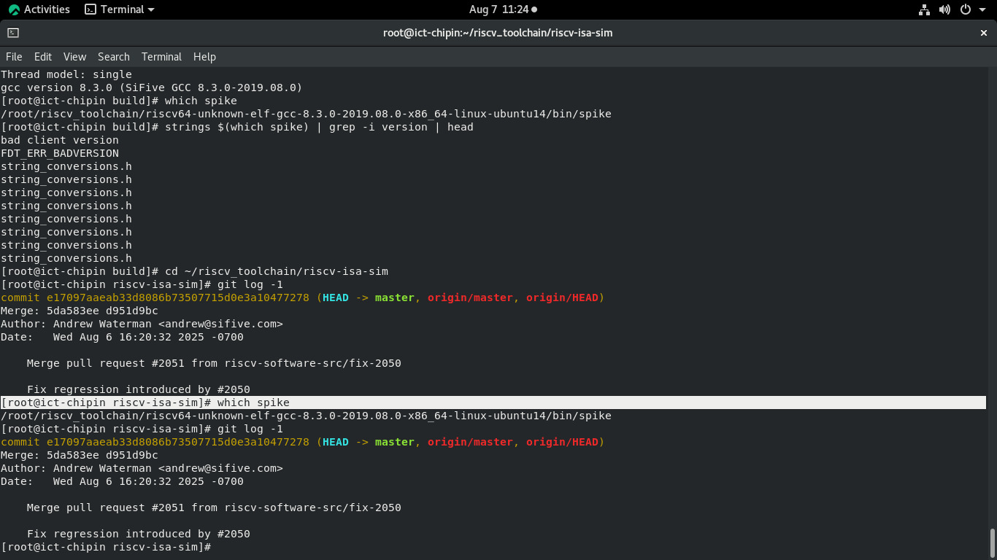GCC toolchain information
3. 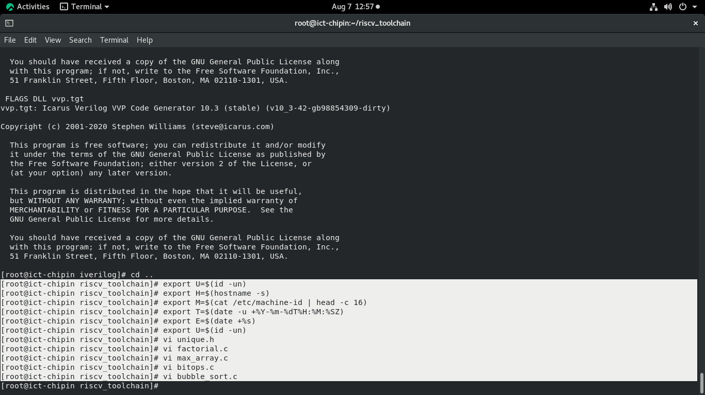Uniqueness mechanism
4. Build, run, and capture evidence
5. 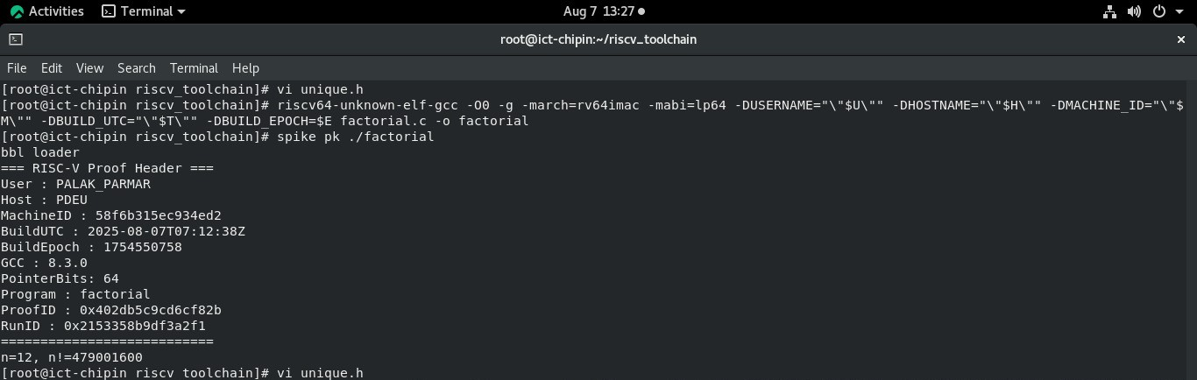factorial.c
6. 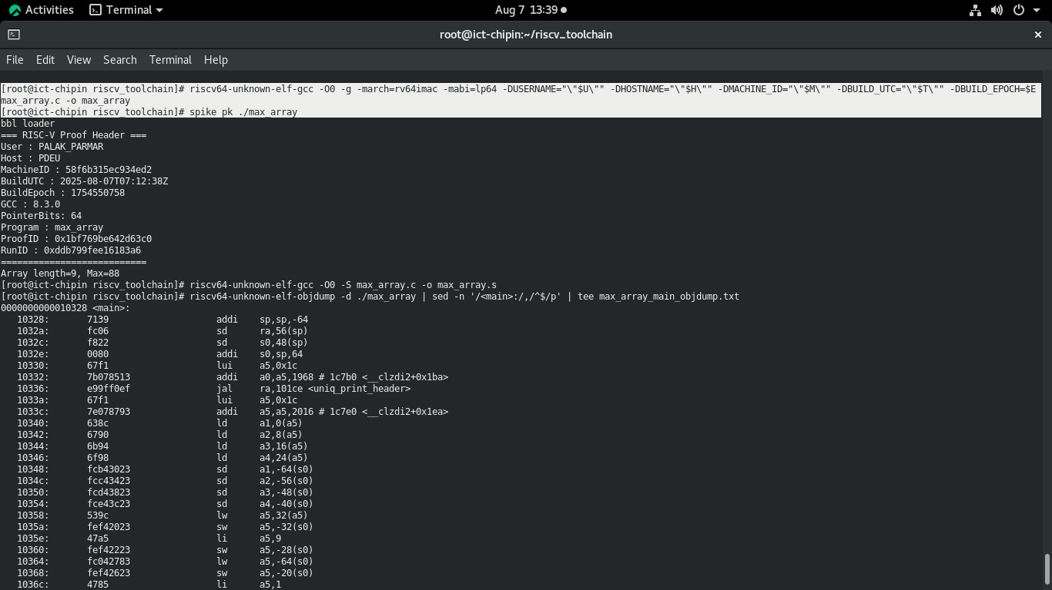max_array.c
7. 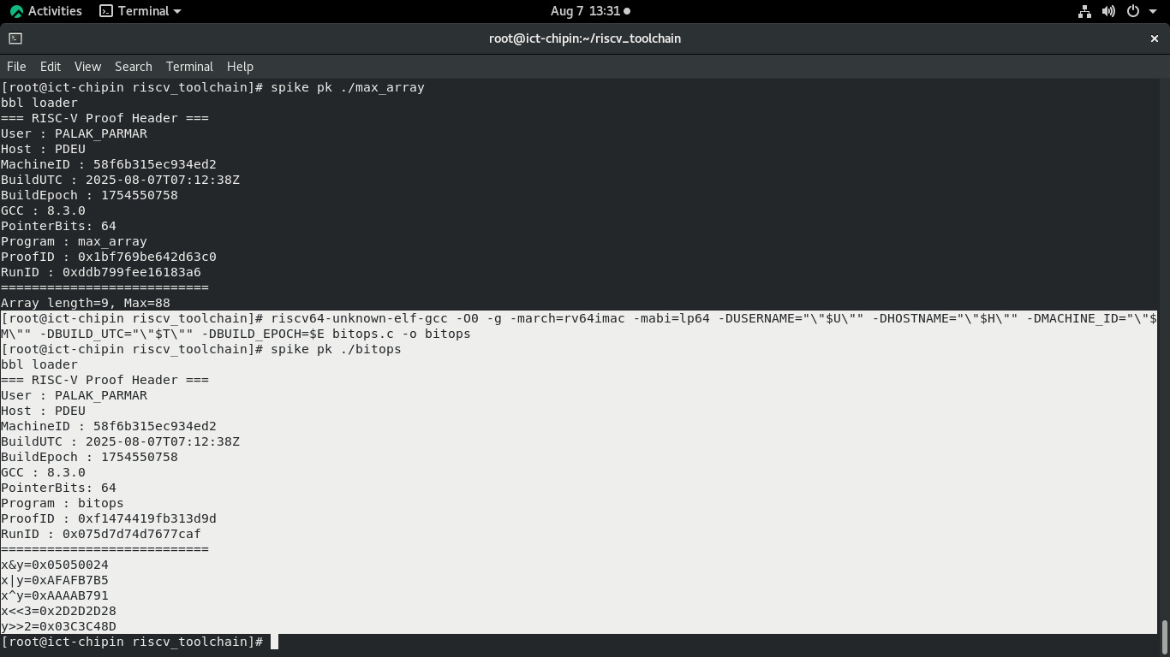bitops.c
8. 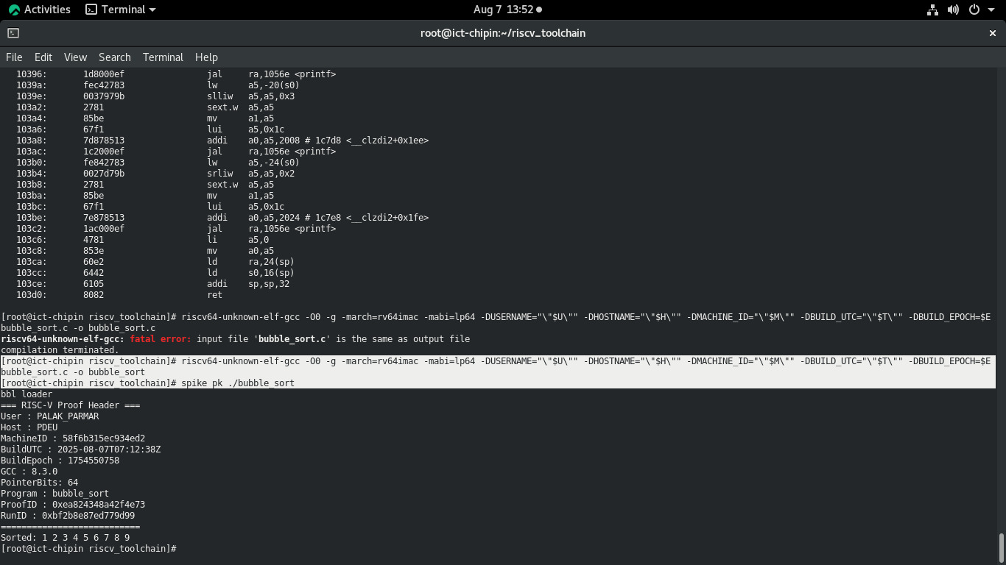bubble_sort.c

**5. Produce assembly and disassembly**

1. 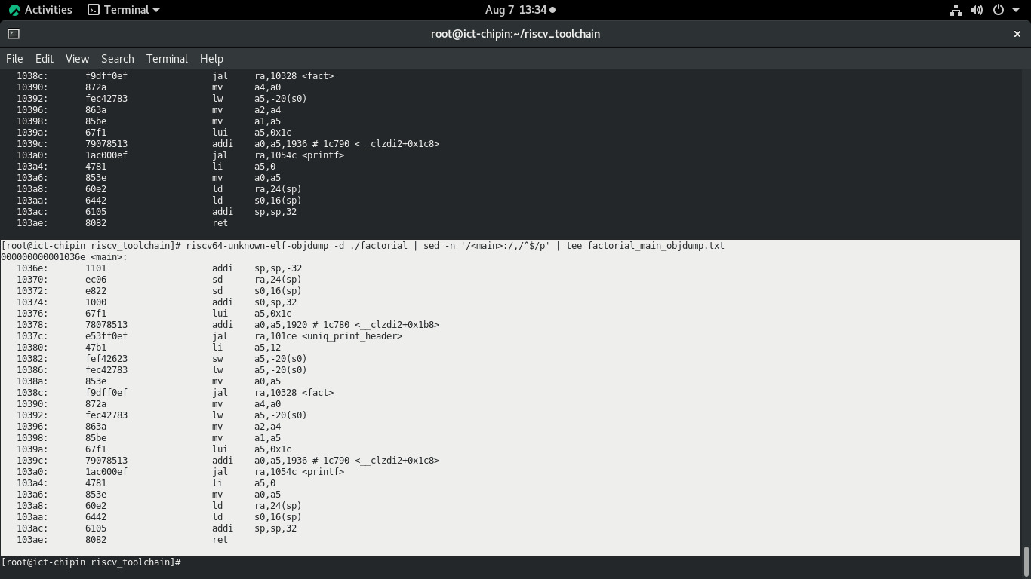factorial.c
2. max_array.c
3. 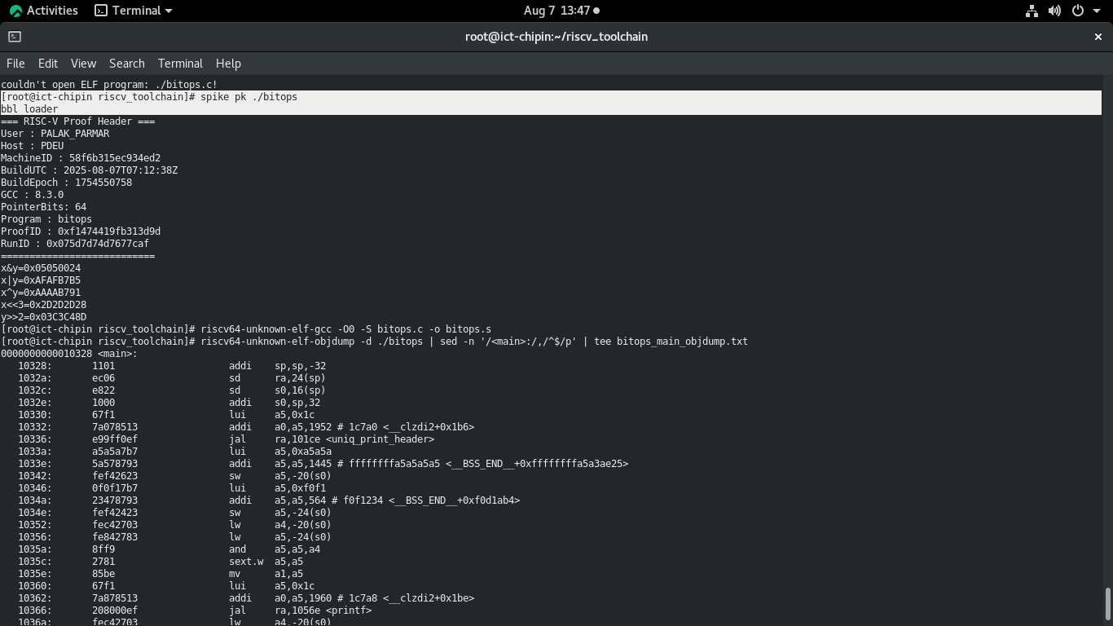bitops.c
4. 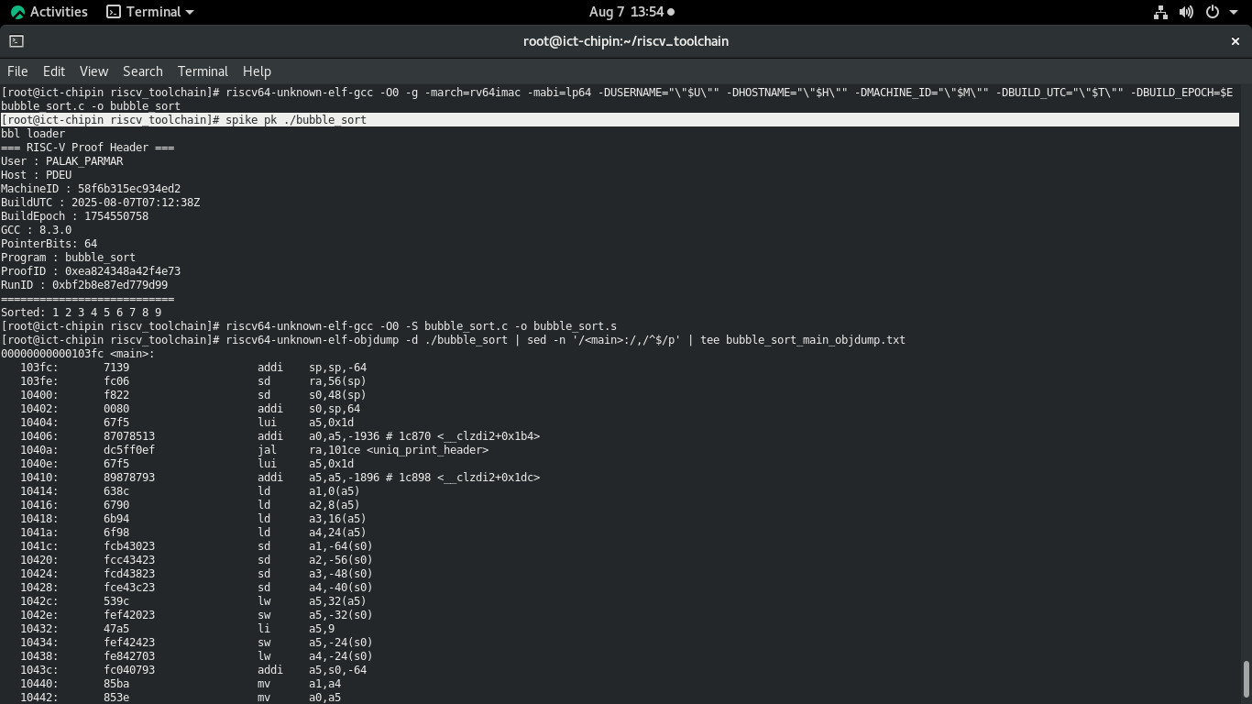bubble_sort